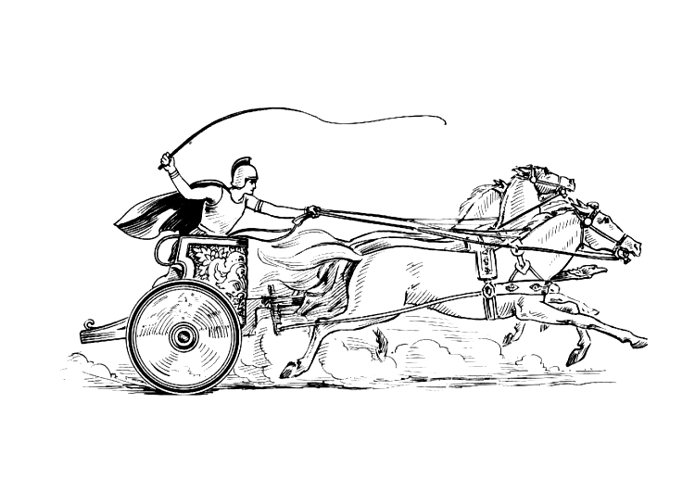Manduessedum - Mancetter Village (Place of War Chariots)
Mancetter Parish Council
Serving the People of Mancetter and Ridge Lane

You are invited to the Parish Council Meeting
to be held in the Schoolroom of St Peter’s Church Mancetter
on Tuesday 25th March 2025 at 7pm.

AGENDA

- Welcome, Apologies, Update on Parish Councillor Vacancy and possible co-option.

- Chairman’s request that anyone recording the meeting make themselves known, to allow
openness and recognise practicalities. An audio recording of the meeting will be
made by the Council, and will be deleted upon production of the draft minutes.

- Declared notice of interest by Councillors concerning agenda items.

- Public Question time of up to 15 Minutes for Members of the Public to raise issues.

- Police, County and Borough Councillor feedback.

- Minutes of the last meetings.

To formally accept the draft minutes of the Parish Council Meetings held on 28th January and 10th February 2025.

- Parish Council Policies and Risk Assessments

- To receive a copy of the new Practitioners Guide 2025 to be used in the forthcoming financial year as part of the Audit Process.
- To adopt the changes to the NALC Financial Regulations in light of the introduction of the Procurement Act and review the Parish Council Financial Risk Assessment.

- Cemetery

- To review cemetery paperwork and consider a change to the policy on pre-selection.
- To determine cemetery fees for the forthcoming financial year.
- To approve an action plan regarding the pruning of yew trees in St Peter’s Churchyard.

- Finance.

- Signing of all payments since the last meeting in accordance with Standing Orders, Financial Regulations and the Bank Mandate.
- Update on the successful collection of allotment rents and allocation of plots.
- To note the 2024/25 Chairman’s discretionary payment as per the approved budget.
- To discuss the possibility of funding commemorative badges for the VE/VJ Day 80th Anniversary.
- Due to the need for disclosure of personal information, a publicly exempt discussion will take place to consider the case for a temporary contract position to undertake some specific tasks.

- Correspondence, Consultations and Meetings involving the
Parish Council (Initials denote speaker)

- To note email correspondence received in Appendix one and update on any matters arising.
- To receive feedback from recent Clerk and Councillor Training (EH,JT)
- To be updated on progress made on the Mancetter Neighbourhood Plan Review.(EH)
- To receive feedback from WCC and NWBC Devolution meetings.(TH, SH)

- Planning Matters and New Applications since the previous meeting.

- Update on Approved and Pending Applications

- PAP/2023/0324 – Outline Access application for the construction of three dwellings to the rear of the White Hart Inn Ridge Lane. Pending following second Planning and Development Board Meeting.

- PAP/2024/0113 – Coachman’s Cottage Purley Chase Lane – proposed new dwelling. Pending.

- PAP/2024/0154 – Greenacres Nuneaton Road –

Change of use of land to extend the extent of land approved for vehicle retail sales [application referenced: PAP/2019/0489] and the erection of a single storey car sales building. Pending.

- PAP/2024/0160 – Greenacres Nuneaton Road –
A new agricultural style building to accommodate an area for preparation of vehicles as well as storage for maintenance equipment and vehicles. Pending.

- County Council Minerals Application NWB/24CM013 Mancetter Quarry, Quarry Lane Mancetter.

Variation of condition 2 cessation of operations and restoration date of NWB/19CM009 and variation of condition 43 of application NWB/14CM034 Pending.

- PAP/2024/0186 - Kirby Glebe Farm Atherstone Road Hartshill –

Change of use to land 150 metres south of Kirby Glebe to accommodate 4 Traveller pitches. - Pending

- PAP/2024/0588 – Crown Stables Nuneaton Road -

Prior approval for proposed conversion of agricultural barn into 1 bungalow.- Pending

- PAP/2024/0590 – Crown Stables Nuneaton Road –

Proposed Custom Build conversion of a former horse stables
into 2 no 2-bedroom bungalows.- Pending

- New Planning Applications since the previous meeting

- PAP/2025/0076 10 The Spinney Mancetter- Single Storey Rear Extension, part garage conversion, Two Storey side extension, first floor side extension over existing garage and study – Comments submitted of No Objection. - Pending

- Date of next meeting- Annual Meeting with Parishioners
Tuesday 29th April 2025
7PM Schoolroom St Peter’s Church Mancetter.
Signed 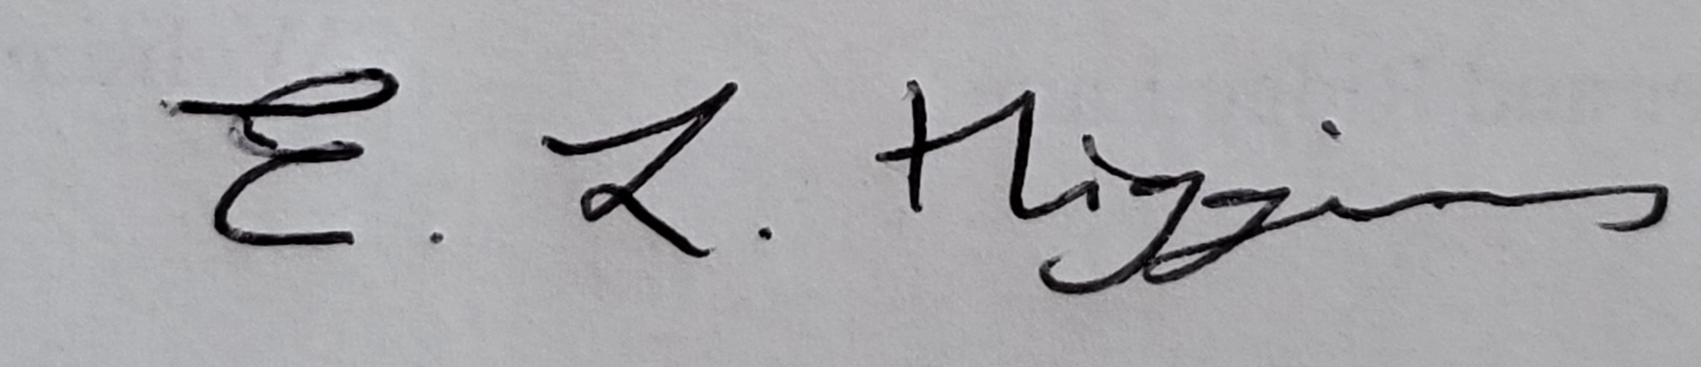
Date 19th March 2025.

Elane Higgins
Parish Clerk Mancetter Memorial Hall Old Farm Road Mancetter CV9 1QN Tel: 01827 722552 Email: parishclerk@mancetterparishcouncil.gov.uk
Website: www.mancetterparishcouncil.gov.uk
Manduessedum - Mancetter Village (Place of War Chariots)
Mancetter Parish Council Serving the People of Mancetter and Ridge Lane

